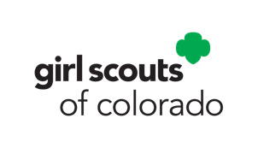

Support Girl Scout sisters with S.O.S. kits

S.O.S. kits are provided by Girl Scouts of Colorado to bring mental wellness activities and supplies to Girl Scouts during times of need. Troops or individuals are invited to create S.O.S. kits and deliver to the GSCO office near you for distribution or donate a component of the kit.

Girl Scouts of Colorado S.O.S Kits will include:
- Coloring book and crayons or colored pencils
- Fidget toys
- Cookies or a shelf-stable snack
- A blanket or wrap to give them a Girl Scout supportive “hug”
- A stuffed animal
- A personalized note from Girl Scout or whomever is giving it
- Backpack or reusable tote bag
- Mindfulness and mental wellness activities provided by Girl Scouts of Colorado

How you can help:
- Create a set of S.O.S. Kits to be distributed and arrange to drop them off at your nearest GSCO office. Each kit should contain all of the items listed above except the mindfulness activities, GSCO will provide those. Each kit should be assembled in a reusable bag or backpack.
- Donate items to be included in S.O.S. kits, such as blankets, snacks, stuffed animals, colored pencils, or fidget toys. Check with staff before donating to ensure the items are still in need and to arrange drop off at a GSCO office.
- Write personalized notes to go in S.O.S. kits.

Who to contact:
S.O.S. kits can be dropped off at any regional GSCO office during regular office hours. Please email sos@gscolorado.org if you want to donate items for S.O.S. kits or if you know a girl who could use an S.O.S. kit.

